Lab E

Brandon Trinkle

Arizona State University

Course Number: IFT 202

Professor Gary Grindle

Feb 4, 2024

Part 1

Task 1

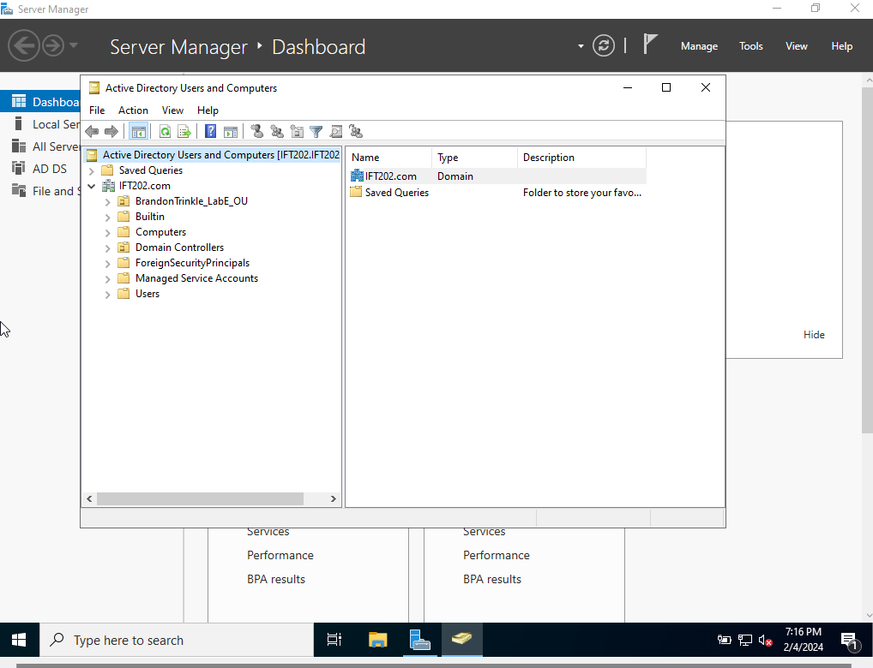

Task 2

Task 3

Task 4

Task 5

Task 6

Task 7

Task 8

